Lab # 05(a) OBJECT

In this lab, you will learn how to verify Default VLAN configuration,
configure VLANs and assign ports to VLANs

THEORY

VLAN:

VLANs allow network administrators to partition their networks to match the functional and security requirements of their systems without having to run new cables or make major changes in their current network infrastructure. Virtual LANs (VLANs) provide segmentation and organizational flexibility in a switched network. A group of devices within a VLAN communicate as if each device was attached to the same cable. VLANs are based on logical connections, instead of physical connections.

Benefits of a VLAN Design

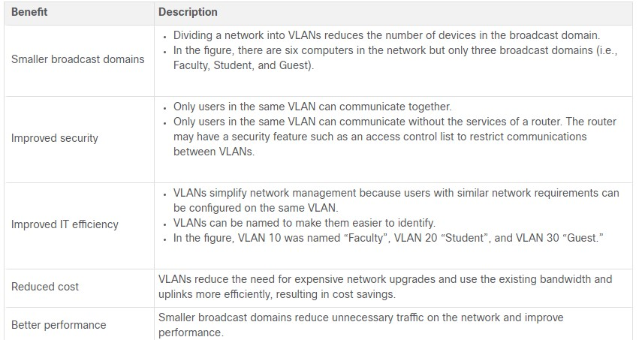

Types of VLANs:

- Default VLAN
- Data VLAN
- Native VLAN
- Management VLAN
- Voice VLAN

Topology:

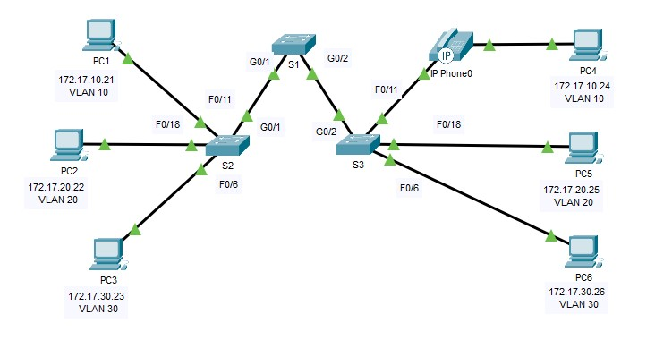

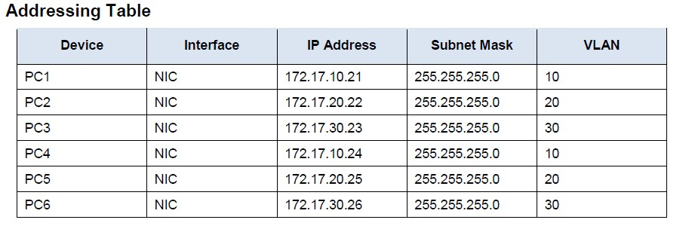

LAB TASK:

- On S1, issue the command that displays all VLANs configured
- Create and name VLANs on S1.
S1#(config)# vlan 10
S1#(config-vlan)# name Faculty/Staff
- Create the remaining VLANS.
VLAN 20: Students
VLAN 30: Guest(Default)
VLAN 99: Management&Native
VLAN 150: VOICE
- Create the same VLANs on S2 and S3.
- Assign VLANs to the active ports on S2
S2(config)# interface f0/11
S2(config-if)# switchport mode access
S2(config-if)# switchport access vlan 10
- Assign the remaining ports to the appropriate VLAN.
VLAN 20: FastEthernet 0/18
VLAN 30: FastEthernet 0/6
- S3 uses the same VLAN access port assignments as S2. Configure the interfaces as access ports and assign the VLANs as follows:
VLAN 10: FastEthernet 0/11
VLAN 20: FastEthernet 0/18
VLAN 30: FastEthernet 0/6
- Assign the VOICE VLAN to FastEthernet 0/11 on S3.
S3(config)# interface f0/11
S3(config-if)# mls qos trust cos
S3(config-if)# switchport voice vlan 150
- Verify loss of connectivity. Try pinging between PC1 and PC4.
S2# show vlan brief
Although the access ports are assigned to the appropriate VLANs, were the pings successful? Explain.

EXERCISES:

- Which command will only display the VLAN name, status, and associated ports on a switch?

__________________________________________________________________ __________________________________________________________________

- What is the Advantage of using the VLANs in your Network?

__________________________________________________________________

Lab # 05(b) OBJECT

In this lab, you will learn about VLAN Trunking Protocol (VTP) and its
Implementation

THEORY

VLAN Trunking Protocol (VTP) :
VTP is CISCO proprietary protocol used to maintain consistency throughout the network or user can say that synchronizing the VLAN information in same VTP domain. VTP allows you to add, delete and rename VLANs which is then propagated to other switches in the VTP domain. VTP advertisements can be sent over 802.1Q, and ISL trunks.

Requirements –

There are some requirements for VTP to communicate VLAN information between switches. These are:

- The VTP version must be same on the switches user wants to configure
- VTP domain name must be same on the switches
- One of the switches must be a server
- Authentication should match if applied

VTP Modes:

VTP server mode – the default mode for Cisco switches. A switch operating in this mode can create, modify, and delete VLANs. You can also specify other VTP configuration parameters on a VTP server, such as VTP version and VTP pruning, for the entire VTP domain. A VTP server switch will propagate VLAN changes. To configure a switch as a VTP server, use the vtp mode server global configuration command.
VTP client mode – a switch operating in this mode can’t change its VLAN configuration. You cannot create, change, or delete VLANs on a VTP client. Received VTP updates will be processed and forwarded. To configure a switch as a VTP client, use the vtp mode client global configuration command.
VTP transparent mode – a switch opering in this mode doesn’t participate in VTP. A VTP transparent switch does not advertise its VLAN configuration and does not synchronize its VLAN configuration based on received advertisements, but it does forward received VTP advertisements. You can create and delete VLANs on a VTP transparent switch, but the changes will not be sent to other switches. To configure a switch to use the VTP transparent mode, use the vtp mode transparent global configuration command.

Topology:

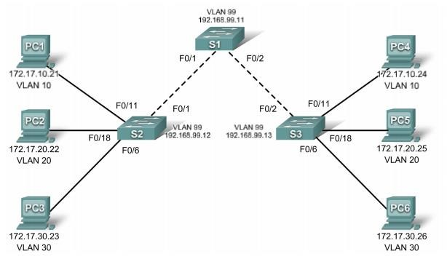

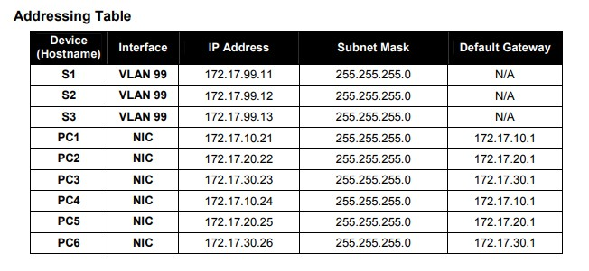

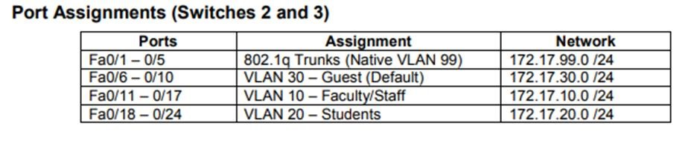

LAB TASK:

- Cable a network that is similar to the one in the topology diagram.
- Configure the user ports in access mode. Refer to the topology diagram to determine which ports are connected to end-user devices.
- Configure VTP on the Switches
- Check the current VTP settings on the three switches. S1#show vtp status
- Configure the operating mode, domain name, and VTP password on all three switches.
Set the VTP domain name to Lab4 and the VTP password to cisco on all three switches. Configure S1 in server mode, S2 in client mode, and S3 in transparent mode.
S1(config)#vtp mode server
Device mode already VTP SERVER.
S1(config)#vtp domain Lab4
Changing VTP domain name from NULL to Lab4
S1(config)#vtp password cisco
Setting device VLAN database password to cisco
S1(config)#end
S2(config)#vtp mode client
Setting device to VTP CLIENT mode
S2(config)#vtp domain Lab4
Changing VTP domain name from NULL to Lab4
S2(config)#vtp password cisco
Setting device VLAN database password to cisco
S2(config)#end
S3(config)#vtp mode transparent
Setting device to VTP TRANSPARENT mode.
S3(config)#vtp domain Lab4
Changing VTP domain name from NULL to Lab4
S3(config)#vtp password cisco
Setting device VLAN database password to cisco
S3(config)#end
- Configure trunking and the native VLAN for the trunking ports on all three switches.
S1(config)#interface range fa0/1-5
S1(config-if-range)#switchport mode trunk
S1(config-if-range)#switchport trunk native vlan 99
S1(config-if-range)#no shutdown
S1(config-if-range)#end
- Configure VLANs on the VTP server
There are four additional VLANS required in this lab:
  - VLAN 99 (management)
  - VLAN 10 (faculty/staff)
  - VLAN 20 (students)
  - VLAN 30 (guest)
Configure these on the VTP server.
S1(config)#vlan 99
S1(config-vlan)#name management
S1(config-vlan)#exit
S1(config)#vlan 10
S1(config-vlan)#name faculty/staff
S1(config-vlan)#exit
S1(config)#vlan 20
S1(config-vlan)#name students
S1(config-vlan)#exit
S1(config)#vlan 30
S1(config-vlan)#name guest
S1(config-vlan)#exit

- Verify that the VLANs have been created on S1 with the show vlan brief command.
- Check if the VLANs created on S1 have been distributed to S2 and S3
S2#show vlan brief

EXERCISES:

- Based on the topology, Are the same VLANs configured on all switches?

__________________________________________________________________ __________________________________________________________________

- Explain why S2 and S3 have different VLAN configurations?

__________________________________________________________________

- When you try to create new VLAN on S2 and S3, Why are you prevented from creating a new VLAN on S2 but not S3?

__________________________________________________________________
__________________________________________________________________
__________________________________________________________________

- What are the Advantages of using VTP?

__________________________________________________________________
__________________________________________________________________ __________________________________________________________________

